**Form PM - 01**

**Project Management Plan/Charter**

**By: Syeda Umema Hani**

**PROJECT MANAGEMENT PLAN TEMPLATE**

**Date: 22/March/ 2007**

**Release #: 1st**

|  |  |  |  |
| --- | --- | --- | --- |
|  |  |  |  |
| **Project Manager** |  |  | **Prime Contractor Manager - (if applicable)** |
|  |  |  |  |

|  |  |  |  |
| --- | --- | --- | --- |
| **State Organization Management** |  |  | **User Management** |
|  |  |  |  |

**Project Manager:** Muhammad Yousuf **Approvals:**

|  |  |  |
| --- | --- | --- |
| **Oversight Manager - (if applicable)** |  |  |
|  |  |  |
| **Department of Finance** |  | ***Other:*** |

HR Department

***1. Project Summary***

|  |  |  |
| --- | --- | --- |
| ***Archiving Management System*** | ***Start Date:*** | ***24/01/2021*** |

Information in the project summary areas was started during the project concept phase and should be included here. ***Project Name:***

|  |  |  |
| --- | --- | --- |
| ***Paf Kiet*** | ***Submitted by:*** | ***Muhammad Yousuf*** |

***State Organization::***

|  |  |  |
| --- | --- | --- |
| ***Maam Syeda Umema Hani*** | ***Date Awarded:*** | ***23/03/2021*** |

***Prime Contractor:***

|  |
| --- |
| ***Development Life Cycle (Concept Refinement) – SPIRAL*** |

***Current Stage of Project:***

|  |  |  |
| --- | --- | --- |
| ***Yes*:**  ***No:***  ***Details: the project build was based on the schedule of completion of 4 months’ duration in the 25% average on per month.*** | ***Project is within***  ***Budget:*** | ***Yes:***  ***No:***  ***Comments: 500$ Budget.*** |

***Project is On Schedule:***

**Please answer the following questions by marking “Yes” or “No” and provide a brief response as *Yes No* appropriate**

|  |  |  |  |  |
| --- | --- | --- | --- | --- |
| Is this an updated Project Plan? If so, reason for Update: No | |  |  |  |
| Budget for project by fiscal year and is project funded? If so, for what amount(s  Budget Amount: 50$  Budget Amount: - Budget Amount: -  Total Budget: 50$ | and period(s): Year: 2021  )  Year: 2022  Year: 2023 | Funded?  Funded?  Funded? | **Yes** | **No**  **No** |

# Project Summary - Continued

***Points of Contact***

This should be the list of individuals that will be involved with the project during the execution phase.

|  |  |  |  |  |
| --- | --- | --- | --- | --- |
| **Position** | **Name/Organization** |  | **Phone** | **E-mail** |
| **Project Manager** | ***Muhammad Yousuf*** | **03456070016** |  | **Ranayousuf2017@gmail.com** |
| **Senior Management Sponsor** | **Faiq Ahmed** | **03343337797** |  | **faiqahmed@gmail.com** |
| **Senior Technical Sponsor** | **Syed Sameed Razi** | **03343337798** |  | **sameedrazi@gmail.com** |
| **Procurement Contact** | **Initial** |  |  |  |
| **Customers:** | **Pakistan Government** |  |  |  |
| **Other Stakeholders (Top 3):** | **Pakistan Document holders** |  |  |  |

***Prime Contractor Information Company:***

|  |  |  |  |  |
| --- | --- | --- | --- | --- |
| **Position** | **Name** |  | **Phone** | **E-mail** |
| **Project Manager** | ***Muhammad Yousuf*** | **03456070016** |  | **Ranayousuf2017@gmail.com** |
| **Senior Technical Sponsor** | **Pakistan Government** | **-** |  | **-** |
| **Contracts Contact** | **Ajmal** | **03343337799** |  | **ajmal@gmail.com** |

***2. Project Charter Business Problem.***

All projects start with a business problem/issue to solve.

The Tracking of document manually is waste of time. so we have developed a software that can store electronic documents in form of files and also keep track of the physical document itself, that where it is held so searching it would take few seconds to get to it .The feature to retrieve document online is the main reason you want to set this software up for your organization

***Statement of Work (Goal).***

The statement should be short and to the point. It should not contain language or terminology that might not be understood.

The AMS project is a new, self-contained system intended for web application. This system intended to replace the manual paper-based storing to digital, high quality, cost effective and reliable flow of documents and files throughout the organization.

The AMS system to be developed benefits greatly the employee’s as well as their supervisor. The other intent of this system is to guide users to easily track and get to a document without any fatigue or hard work. Web apps serve as the frontend, AMS backend responsible for database and information transaction, CRUD services.

1. **Login**
2. **User Registration**
3. **Document Registration**
4. **Document Encrypt and Decrypt**
5. **Department Registration**
6. **Log Maintaining**

***2. Project Charter, continued Project Objectives:***

Provide a brief, concise list of what the project is to accomplish.

|  |
| --- |
| This product is just a modern way to archive documents and files in a manner that retrieving and searching becomes easier and fasters;   1. Authentication, Access level of User, Roles, Security 2. User, User Roles, User Access level 3. Document , Document Access level, Document Searching , Physical Document Tracking 4. Document Encryption and Decryption 5. Log Maintaining of users that do any curd operations     This Project is specifically focused over Module 1 and 5 |

***Success Factors:***

List factors that will be used to determine the success of the project.

1. Complete deployment of all 4 modules
2. Smooth integration between all systems
3. Effacingly error resolve

***Project Dependencies/Constraints:***

|  |  |  |
| --- | --- | --- |
| **Project completion is expected in less than**  **All requirements will be 100% available during requirement phase Maximum team strength 5** | **3.5 months** | **duration** |
|  |

***3. Project Tradeoff Matrix & Status Summary***

|  |  |  |
| --- | --- | --- |
| **Schedule/Time** | **Scope/Modules** | **Resources/Effort/People** |
| CONSTRAINED | **ACCEPTED** | **IMPROVED** |

Identify variable to be CONSTRAINED, IMPROVED, ACCEPTED

***Comments:***

**Accepted**

**+/- Status (Review and Progress Meeting)**

|  |  |  |  |  |  |
| --- | --- | --- | --- | --- | --- |
|  | **Team** | **Tech** | **Schedule** | **Cost** | **Comment** |
| RM 1 | Requirement SRS | + | / | / | SRS Submission |
| RM 2 | PMP | / | - | / | PMP Submission |
| RM 3 | Modeling | -/+ | -/+ | -/+ | Done already in SRS |
| RM 4 | Coding and Testing | -/+ | -/+ | -/+ | Testing Report Submission |
| RM 4 | Demo / Deployment | -/+ | -/+ | -/+ | Final Project Report Submission |

Discuss:

**Legend**

+ = Ahead of Schedule

- = Behind Schedule

/ = On Schedule

## 4. Project Organization

*Provide an organization chart that defines the person responsible for at least the following functions: project manager, development manager, quality assurance, and configuration management.*

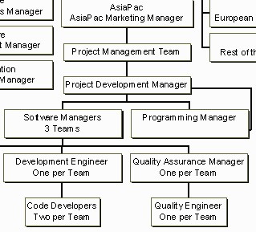

RE team



5

SOFTWARE

ENGINEERS



Co

-

PM or Team lead/ GL



**Archiving Management**



**Muhammad Yousuf / Admin / Tester**



**Synfox Global**

***SDLC Process Model:***

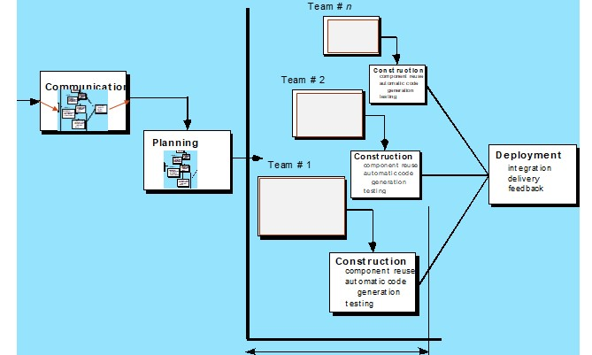

5

## 5. Activity List (Work Breakdown Structure)

Provide an activity list (*work breakdown structure*) *that describes each task required by the project, with a reference to the statement of work. For large projects, work packages might be included that describe in detail how specific tasks will be completed by specific project teams. These work packages describe required schedule, identify requirements to be completed and describe specific work to be performed*

1. **First Estimating FP then from it E and S.**

|  |  |  |  |  |  |  |  |  |  |  |  |  |  |  |
| --- | --- | --- | --- | --- | --- | --- | --- | --- | --- | --- | --- | --- | --- | --- |
| **Software Size Estimation using Function Point Method** | | | | | | | | | | | | | | |
|  | | | | | | | | | | | | | | |
|  | **A) Detail of 5 Transaction Types, at most 5 under each category** | | | | | | | | | | | |  | |
|  | | Write down exact Screen or Forms names, or Tables, or Reports name for each count value. | | | | | | | | | |
| EI | | 1. Login Form 2. User Form 3. Department Form 4. Document Form 5. Rack/Box Form | | | | | | | | | |
| EO | | 1. Users List 2. Document List 3. Log List 4. Department List 5. Rack/Box List | | | | | | | | | |
| EQ | | 1. Authentication 2. Department Exists 3. User Role 4. User Access Level 5. Document Access Level | | | | | | | | | |
| ILF | | 1. Lists 2. Login 3. Document Status 4. Logs 5. Details | | | | | | | | | |
| ELF | | 1. - 2. - 3. - 4. - 5. _____-_____ | | | | | | | | | |
|  | | | | | | | | | | | | | | |
|  | **B) Unadjusted Function Point Value calculation** | | | | | | | | | | | | |  |
| **Definition of Complexities:** Your Transactions which are derived from only from 1 Table are to be categorized as Low and if they are derive from 2 tables they can be categorized in Mid-level complexity, and in case of >= 3 they will be placed under High level of complexity. | | | | | | | | | | | | |
|  | Count for screens of Low level complexity  (C) | | Multiplier Low level complexity  (M) | V1  =  C  *  M | Count for screens of Mid-level complexity  (C) | Multiplier Mid-level complexity  (M) | V2  =  C  *  M | Count for screens of High-level complexity  (C) | Multiplier High-level complexity  (M) | V3  =  C  *  M | Category wise sum V1+V2+V3 | |
| EI | 3 | | 3 | 9 | 3 | 4 | 12 | 3 | 6 | 18 | 39 | |
| EO | 3 | | 4 | 12 | 3 | 5 | 15 | 3 | 7 | 21 | 48 | |
| EQ | 2 | | 3 | 6 | 2 | 7 | 14 | 2 | 6 | 12 | 32 | |

|  |  |  |  |  |  |  |  |  |  |  |  |  |  |
| --- | --- | --- | --- | --- | --- | --- | --- | --- | --- | --- | --- | --- | --- |
|  | | ILF | 1 | 7 | 7 | 1 | 0 | 0 | 1 | 15 | 15 | 22 |  |
| ELF | 1 | 5 | 5 | 1 | 7 | 7 | 1 | 10 | 10 | 22 |
| **Unadjusted Function Point Value =** | | | | | | | | | | **163** |
|  | | | | | | | | | | |
| |  |  |  |  |  |  | | --- | --- | --- | --- | --- | --- | | **C) Value Adjustment Factor (VAF) calculation** | | | | | | | **Note:** Calculate Value Adjustment Factor, where any 5 "General System Characteristics (GSC) must have a value above 2. Also show respect Quality Characteristic mapping of these 5 factors. | | | | | | |  | Quality  Characteristic | Weight (0-5) |  | Quality  Characteristic | Weight (0-5) | | 1. |  | 3 | 8. |  | 3 | | 2. |  | 2 | 9. |  | 2 | | 3. |  | 1 | 10. |  | 4 | | 4. |  | 4 | 11. |  | 1 | | 5. |  | 5 | 12. |  | 3 | | 6. |  | 0 | 13. |  | 2 | | 7. |  | 1 | 14. |  | 0 | | **Value Adjustment Factor (VAF) = 32** | | | | | | | | | | | | | | | | | | | |
| **D) Technology Complexity Factor calculation**    TCF = 0.65 + (VAF * 0.01)  = 0.65 +(32*0.01)  = 0.97 | | | | | | | | | | | | | |
| **E) Adjusted Function Point Value (AFPV) or Function Point Value (FP) Calculation**    AFPV = _ Unadjusted Function Point * TCF  = 163 * 0.97  = 158.11 | | | | | | | | | | | | | |
| **F) Conversion of AFPV in to LOC Size metric**  the number of LOCs per FP for C# language 54 and check other languages from [https://www.qsm.com/resources/functionpoint-languages-table,](https://www.qsm.com/resources/function-point-languages-table) ASP 51 and VB.net 52 | | | | | | | | | | | | | |
|  | | Project Size in LOC = AFPV * LOC/FP  Project Size in LOC = 158.11 * 54 = 8537.94 LOC | | | | | | | | | | | | |  |
| **G)** Software Size: 8537.94  Software Size for COCOMO: 8.537 KLOC  Software Type: **Business**/ Utility/Embedded  Model Mode: Cocomo I – Basic – **ORGANIC (0 – 50 KLOC)** / Semi detached/Embedded | | | | | | | | | | | | |
| a) **Effort Estimation:** Equation  2.4 * 8.537 ^ 1.05 **= 22.80 mm** | | | | | | | | | | | | |
| b) **Schedule Estimation:** Equation  2.5 * **22.80** ^ 0.38 months **= 8.20 months** | | | | | | | | | | | | |
| c) **Productivity Estimation:** Equation Loc/E = 8537.94 /**8.20**  => 374.47 | | | | | | | | | | | | |
| d) **Average Loading Estimation:** Equation E/S = 2.78 | | | | | | | | | | | | |
| e) **Average Salary of Technical Staff (AS):** Equation Assume = 50,000 RS | | | | | | | | | | | | |
| f) **Cost for Salary (Cs):** Equation E * Avg salary = 1140000 | | | | | | | | | | | | |
| g) **Budgeted Cost of Project (Cb):** Equation  Cs + Cs * X% = Cb  1140000 + (1140000 * 2%) = 1162800 | | | | | | | | | | | | |

|  |  |  |  |  |  |  |  |
| --- | --- | --- | --- | --- | --- | --- | --- |
|  | | **H) Distribution of Effort and Schedule among Different phases of SDLC** | | | |  | |
| **E = 22.80 S = 8.20** | |  | | | |  | |
| **Plan and Requirement** | | **Modeling / System Design & Detailed Design** | | **Module Coding and Unit Testing** | | **Integration & Deployment** | |
| 0.06 * E = | 0.10 * S = | (0.16+0.26) * E = | (0.19+0.24) S = | 0.42 * E = | 0.39 * S = | 0.16 * E = | 0.18 * S = |
| 1.368 | 0.82 | 9.576 | 3.526 | 9.576 | 2.198 | 3.648 | 1.476 |

1. **Calculate the phase-wise percentage distribution wise E and S values as given in detailed COCOMO detailed model.**

1. **Now adding percentage distribution as given in detailed COCOMO model in the WBS phase-wise.**

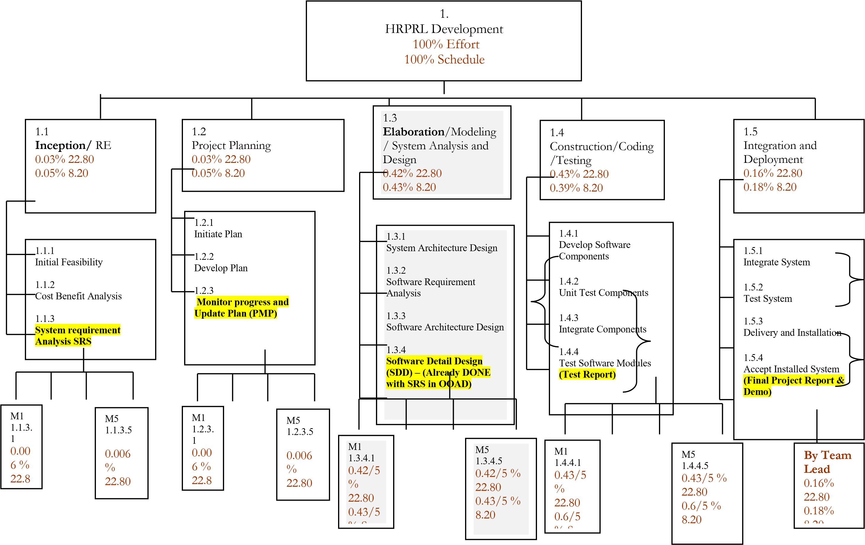

1. **Now convert WBS contents in a Tabular format in order to make a GANTT CHART.**

|  |  |  |  |  |  |  |
| --- | --- | --- | --- | --- | --- | --- |
| **Activity #** | **Activity Name** | **Activity Name Description** | **# of Days** | **Start Date** | **Dependency on previous tasks** | **Milestone** |
| **1.1** | **RE** | **Requirement Engineering** | **28** | **24/1/2021** | **none** | **21/2/2021** |
| **1.1.1** | **Initial Feasibility** |  | 18 | 2/03/2021 | none | 3/03/2021 |
| **1.1.2** | **Cost Benefit Analysis** |  | 18 | 4/03/2021 | none | 5/03/2021 |
| **1.1.3** | **System requirement Analysis SRS** |  | 18 | 6/03/2021 | none | 7/03/2021 |
| 1.1.3.1 | System requirement Analysis SRS **for Module 1** |  | 18 | 8/03/2021 | none | 9/03/2021 |
| 1.1.3.2 | System requirement Analysis SRS **for Module 2** |  | 18 | 10/03/2021 | none | 11/03/2021 |
| 1.1.3.3 | System requirement Analysis SRS **for Module 3** |  | 18 | 12/03/2021 | none | 13/03/2021 |
| 1.1.3.4 | System requirement Analysis SRS **for Module 4** |  | 18 | 12/03/2021 | none | 13/03/2021 |
| 1.1.3.5 | System requirement Analysis SRS **for Module 5** |  | 18 | 12/03/2021 | none | 14/03/2021 |
| **1.2** | **Project Planning** | **Project**  **Management**  **Planning** | 18 | **15/3/2021** | **1.1** | **5/4/2021** |

## 6. Work Product Identification

*Provide a list of all deliverables required by the project, the date due and the person responsible for the deliverable. Pick Last activities from each phase they are deliverables.*

|  |  |  |  |
| --- | --- | --- | --- |
| ***Deliverable Name*** | ***Due Date*** | ***Date Delivered*** | ***Point of Contact*** |
| SRS by Member 1 | 21/2/2021 | 22/2/2021 | 9318 |
| SRS by Member 2 | 21/2/2021 | 21/2/2021 | 9325 |
| SRS by Member 3 | 21/2/2021 | 21/2/2021 | 9308 |
| SRS by Member 4 | 21/2/2021 | 21/2/2021 | 8860 |
| SRS by Member 5 | 21/2/2021 | 21/2/2021 | 9061 |
| PMP by Member 1 | 5/4/2021 | 5/4/2021 | 9318 |
| PMP by Member 2 | 5/4/2021 | 5/4/2021 | 9325 |
| PMP by Member 3 | 5/4/2021 | 5/4/2021 | 9308 |
| PMP by Member 4 | 5/4/2021 | 6/4/2021 | 8860 |
| PMP by Member 5 | 5/4/2021 | 5/4/2021 | 9061 |

## 7. SCHEDULE

*Provide the project schedule, using a Gantt chart. The schedule must include milestones, task dependencies, task duration, work product delivery dates, quality milestones (reviews/audits/inspections), configuration management milestones, and action items (with deadlines and responsibilities).*

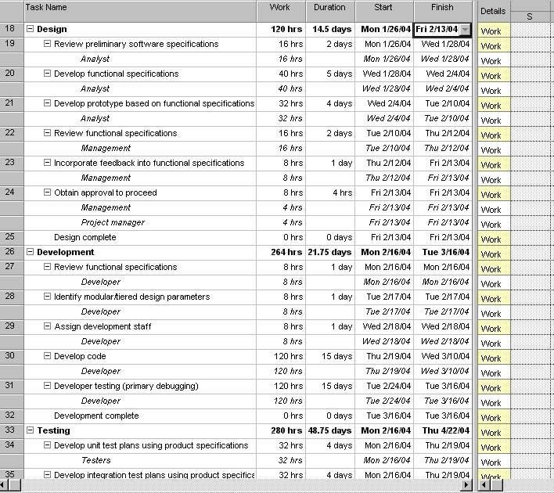

|  |  |  |  |  |  |  |  |  |  |  |  |  |  |
| --- | --- | --- | --- | --- | --- | --- | --- | --- | --- | --- | --- | --- | --- |
| Work Packages, Tasks &  Activities | | Week | | | | | | | | | | | |
| 1 | 2 | 3 | 4 | 5 | 6 | 7 | 8 | 9 | 10 | 11 | 12 |
| Concept Exploration | Internal Case Study |  |  |  |  |  |  |  |  |  |  |  |  |
| Communicate with CRM |  |  |  |  |  |  |  |  |  |  |  |  |
| Initial Project Plan | SPMP Pass #1 |  |  |  |  |  |  |  |  |  |  |  |  |
| Review by CRM |  |  |  |  |  |  |  |  |  |  |  |  |
| SPMP Pass #2 |  |  |  |  |  |  |  |  |  |  |  |  |
| Travel & Orientation | Meeting with  CRM  Representatives |  |  |  |  |  |  |  |  |  |  |  |  |
| Meeting with 26 programmers |  |  |  |  |  |  |  |  |  |  |  |  |
| Recruiting into  Organizational  Chart |  |  |  |  |  |  |  |  |  |  |  |  |
| OOP Training |  |  |  |  |  |  |  |  |  |  |  |  |
| Initial SRS | SRS Pass #1 |  |  |  |  |  |  |  |  |  |  |  |  |
| Prototype 1 (Screens) |  |  |  |  |  |  |  |  |  |  |  |  |
| SRS Review by Team |  |  |  |  |  |  |  |  |  |  |  |  |
| Final SPMP | Pass #3 |  |  |  |  |  |  |  |  |  |  |  |  |
| Final SRS | SRS Review as per SPMP |  |  |  |  |  |  |  |  |  |  |  |  |
| SRS Submission to CRM |  |  |  |  |  |  |  |  |  |  |  |  |
| Design | High level Design |  |  |  |  |  |  |  |  |  |  |  |  |
| High Level Review |  |  |  |  |  |  |  |  |  |  |  |  |
| Prototype 2 |  |  |  |  |  |  |  |  |  |  |  |  |
| Detail Level Design |  |  |  |  |  |  |  |  |  |  |  |  |

|  |  |  |  |  |  |  |  |  |  |  |  |  |  |
| --- | --- | --- | --- | --- | --- | --- | --- | --- | --- | --- | --- | --- | --- |
|  | Detail Level Review |  |  |  |  |  |  |  |  |  |  |  |  |
| Prototype 3 |  |  |  |  |  |  |  |  |  |  |  |  |
| System Construction | Source Code &  Executable Program |  |  |  |  |  |  |  |  |  |  |  |  |
| Review by CRM |  |  |  |  |  |  |  |  |  |  |  |  |
| System  Verification & Validation | Testing Summary Report |  |  |  |  |  |  |  |  |  |  |  |  |
| Review by CRM |  |  |  |  |  |  |  |  |  |  |  |  |
| Customer  Acceptance  Feedback |  |  |  |  |  |  |  |  |  |  |  |  |
| System  Delivery | System Delivery & Maintenance |  |  |  |  |  |  |  |  |  |  |  |  |

## 8. Estimated Cost at Completion

Provide an estimated cost at completion, which is an assessment of the total effort at completion of the contract.

***Analysis in Hours Analysis in Dollars***

|  |  |  |  |  |  |  |  |  |  |  |  |
| --- | --- | --- | --- | --- | --- | --- | --- | --- | --- | --- | --- |
| ***WBS***  ***No.*** | ***Activity Description*** | ***Budget Hours*** | ***Actual Hours*** | ***Est. to***  ***Complete remaining work*** | ***Est. @***  ***Complete of project*** | ***Variance (+ = More)*** | ***Budget $*** | ***Actual $*** | ***Est. to***  ***Complete*** | ***Est. @ Complete*** | ***Variance (+ = More)*** |
|  |  |  |  | ***A+ @*** | ***@ = B-A*** | ***a-b/a*** |  |  |  |  |  |
| ***1*** | ***Conceptual design*** | ***6*** | ***10*** | ***10+6=16*** | ***10-6=4*** | ***16-4/16=***  ***0.75*** | ***30*** | ***50*** | ***80*** | ***20*** | ***80-20/80=***  ***0.75*** |
| ***2*** | ***Utilities*** | ***5*** | ***10*** | ***10+5=15*** | ***10-5=5*** | ***15-5/15=***  ***0.667*** | ***25*** | ***50*** | ***75*** | ***25*** | ***75-25/75=***  ***0.666*** |
| ***3*** | ***Planning*** | ***4*** | ***10*** | ***10+4=14*** | ***10-4=6*** | ***14-6/14=***  ***0.571*** | ***20*** | ***50*** | ***70*** | ***30*** | ***70-30/70=***  ***0.571*** |
| ***4*** | ***Testing*** | ***5*** | ***15*** | ***15+5=20*** | ***15-5=10*** | ***20-10/20=***  ***0.5*** | ***25*** | ***60*** | ***85*** | ***35*** | ***85-35/85=***  ***0.625*** |
| ***5*** | ***Modules*** | ***7*** | ***15*** | ***15+7=22*** | ***15-7=8*** | ***22-8/22=***  ***0.636*** | ***35*** | ***50*** | ***85*** | ***15*** | ***85-15/85=***  ***0.82*** |
| ***6*** | ***Forms*** | ***12*** | ***15*** | ***15+12=27*** | ***15-12=3*** | ***27-3/27=***  ***0.888*** | ***50*** | ***60*** | ***110*** | ***10*** | ***11010/110=***  ***0.909*** |

***9. Resource Loading Profiles - Staffing***

*Provide a staffing plan that shows the number of personnel, by type, that will be required on the project on a monthly basis*.

|  |  |  |
| --- | --- | --- |
| **Organization** | **Liaison- interfaces** | **Contact Information** |
| Customer: APMM | Don Shafer | 86-1-5128931 |
| Subcontractor: None | Don Shafer | Ranayousuf2017@gmail.com |
| Software Quality Assurance:  CRM | Don Shafer | Ajmal@gmail.com |
| Software Configuration Management: Team 2 | Don Shafer | sameed@gmail.com |
| Change Control: Team 2 | Don Shafer | abdullah@gmail.com |

|  |  |  |
| --- | --- | --- |
| **Role** | **Description** | **Person** |
| Project Leader | Leads project team; responsible for project deliverables | Muhammad Yousuf |
| Project  Management  Team/Analysts | Assisting in building SPMP, SRS and prototype, as well as doing the necessary requirement and risk analysis for  the project | Ajmal Iqbal |
| Project  Development Manager | Leads Chinese software developers; responsible for project deliverables | Sameed Razi |
| Programming Manager | Responsible for the communication between the  Management Team and the rest of the software development team; the Programming Manager is also responsible for reallocating the human resources and equipment of the project. | Faiq Ahmed |

|  |  |  |  |  |
| --- | --- | --- | --- | --- |
|  | Software Managers | Responsible for managing the team of 7 people; does the design of the software; after reviewing reports from Test  Engineer decides whether code needs to be sent back to  Development Engineer for improvement or to be send to Quality Assurance Manager for quality assurance phase | Muhammad Yousuf |  |
| Development Engineers | Responsible for designing of software and distributing work among Code Developers | Sameed Razi |
| Code Developers | Responsible for writing programming code | Muhammad  Abdullah |
| Test Engineer | Responsible for testing and validation process in his/her team; leads Test Technician in the testing process and reports the results of the testing process to the software  manager | Ajmal Iqbal |
| Test Technician | Performs the testing and validation procedure; reports found errors to Test Engineer | Faiq Ahmed  Siddiqui |
| Quality  Assurance  Manager | Responsible for quality assurance; reports to Software Manager and Project Development Manager | Muhammad Yousuf |
| Quality Engineer | Performs quality assurance procedure; reports the results to Quality Assurance Manager | Sameed Razi |

### 10. Project Requirements

Provide a detailed listing of project requirements, with references, to the statement of work, work breakdown structure, and specifications.

|  |  |  |  |  |  |  |  |
| --- | --- | --- | --- | --- | --- | --- | --- |
| No. | Requirement | RFP  Reference  Not submitted by the  client in Adv. | SOW  Reference | WBS Task Reference | Specification Reference | Date Completed | Comments/Clarification |
| 1. | **3.1.1 Login** | **N/A** | **1** | **1.1.3.1**  **1.2.3.1**  **1.3.4.1**  **1.4.4.1** | **3.1.1** | **5/4/2021** |  |
| 2. | **3.1.2 Module 1 CRUDS** | **N/A** | **2** | **1.1.3.2** | **3.1.2** | **5/4/2021** |  |
| 3. | **3.1.3 Module 2 CRUDS** | **N/A** | **3** | **1.1.3.3** | **3.1.3** | **5/4/2021** |  |
| 4. | **3.1.4 Module 3 CRUDS** | **N/A** | **4** | **1.1.3.4** | **3.1.4** | **5/4/2021** |  |
| 5. | **3.1.5 Module 4 CRUDS** | **N/A** | **5** | **1.1.3.5** | **3.1.5** | **5/4/2021** |  |
| 6. | **3.1.6 Module 5 CRUDS** | **N/A** | **6** | **1.1.3.6** | **3.1.6** | **5/4/2021** |  |

SOW = Statement of Work

### 11. Risk Identification

*Provide a description of all risks identified for the project. A risk is anything that might detrimentally affect the successful completion of the project if left unaddressed. The contractual, management, and technical risks associated should be identified and assessed as to the probability of the risk occurring, the cost to correct if the risk occurs, the impact of the risk on the project, and the suggested mitigation activities and cost of mitigation.*

#### Risk Worksheet

Last Risk Assessment Date: Prepared by:

|  |  |  |  |  |  |  |  |  |
| --- | --- | --- | --- | --- | --- | --- | --- | --- |
| ***Risk Category/ Event*** | ***Loss Hours*** | ***Probab ility*** | ***Risk Hours*** | ***Previous***  ***Risk***  ***Hours*** | ***Preventive Measures*** | ***Contingency Measures*** |  | ***Comments*** |
| ***Meeting (SRS)*** |  |  |  |  |  |  |  |  |
| **1. Size of software** | **12hr,** | **50** | **12hr,** | **12hr,** | **Being flexible in the software design** | **Proactive** | **NO** |  |
| **2. Customer requirement may change** | **12hr,** | **50** | **12hr,** | **12hr,** | **A new prototype will replace the pervious**  **one to accommodate the change** | **Active** | **NO** |  |
| **3. Technology will not meet expectation** | **12hr,** | **50** | **12hr,** | **12hr,** | **Exploring alternatives for the outdated technologies** | **Proactive** | **NO** |  |
| **4. Unexperience**  **d staff and lack of training** | **12hr,** | **50** | **12hr,** | **12hr,** | **Providing adequate training that is necessary** | **Proactive** | **NO** |  |
| **5. Delivery not being on time** | **12hr,** | **50** | **12hr,** | **12hr,** | **Setting deadlines before the actual**  **times for the project submission** | **Proactive** | **NO** | |
| **Meeting (PMP)** |  |  |  |  |  |  |  | |
| **1. Performance**  **shortfall** | **24hr,** | **50=0.5** | **12hr,** | **12hr,** | **Check on employee** | **Risk occurs**    **Survival and first aid** | **NO** | |
| **2. Personal**  **shortfall** | **24hr,** | **100%**  **= 1** | **4hr,** | **4hr,** | **Hiring top talent** | **Marketing strategy change, partially code change.** | **NO** | |
| **3. Unrealistic budget** | **24hr,** | **70** | **4hr,** | **4hr,** | **Budget should be finalize after**  **considering past experience** | **Marketing strategy change** | **NO** | |
| **4. Developing wrong software** | **24hr,** | **70** | **4hr,** | **4hr,** | **Analysis after specific interval.** | **Mistakes** | **NO** | |
| **5. Software not accepted by customers** | **24hr,** | **70** | **4hr,** | **4hr,** | **Involve customer for analysis** | **Failure happened** | **NO** | |

General Risk Analysis Comments:

|  |  |  |  |
| --- | --- | --- | --- |
| **Risk Items** | | **Risk Management Techniques** | |
| Personnel Shortfalls | | Staffing with top talent, job matching; team building; morale building; cross training; pre-scheduling key people | |
| Unrealistic schedules and budgets | | Detailed, multi source cost and schedule estimation; design to cost; incremental development; software reuse; requirement scrubbing | |
| Developing the wrong software functions | | Organizational analysis; mission analysis; ops-concept formulation; user surveys; prototyping; early users' manuals | |
| Developing the wrong user interface | | Task analysis; prototyping; scenarios; user characterization (functionality, style, workload) | |
| Gold Plating | | Requirement scrubbing; prototyping; cost-benefit analysis; design to cost | |
| Continuing stream of requirement changes | | High change threshold; information hiding; incremental development (defer changes to later increments) | |

Shortfalls in externally Benchmarking; inspections; reference checking; compatibility furnished components analysis

|  |  |
| --- | --- |
| Shortfalls in externally performed tasks | Reference checking; pre-award audits; award-fee contracts; competitive design or prototyping team building |
| Real-time  performance shortfalls | Simulation; benchmarking; modeling; prototyping; instrumentation; tuning |
| Straining computerscience capabilities | Technical analysis; cost-benefit analysis; prototyping; reference checking |

**Risk Management:**

|  |  |
| --- | --- |
| 1 | Identify the project’s top10 risk items |
| 2 | Present a plan for resolving each risk item |
| 3 | Update list of top risk items, plan, and results monthly |
| 4 | Highlight risk-item status in monthly project reviews.  Compare with previous month’s ranking status |
| 5 | Initiate appropriate corrective actions |

### 12. Configuration Management Plan

Provide a configuration management plan that defines the person responsible for project configuration management, the procedures that will be used, the planned configuration items, planned release dates for configuration items, and resources required to conduct CM.

*CM Responsibility*

*Manager: Muhammad Yousuf*

*Additional Staff for CM: Ajmal Iqbal*

*Procedure Reference:*

Configuration Items:. Ensure that CM is implemented throughout the project’s life cycle.

|  |  |  |
| --- | --- | --- |
| No. | Item | Comments |
| 1. | **Hardware** | **Hardware should support the software.** |
| 2. | **Software** | **Software should be accessible to everyone.** |
| 3. | **Database** | **Software should be linked with database.** |

*Ensure that project has a repository for storing configuration items and associated CM records. Briefly describe.*

*The project has the repository for storing configuration items and CM records. If any change needed in the project, we will implemented it in our project.*

### 13. Quality Plan

Provide a quality plan that defines the person responsible for project quality assurance, the procedures that will be used and resources required to conduct quality assurance.

*QA Responsibility*

*Manager: Muhammad Yousuf*

*Additional Staff for QA: Sameed Razi*

*Procedure Reference: The project is implemented as per plan*

Planned Quality Event: Ensure that QA is implemented throughout the project’s life cycle. Dates include QA audits and reviews, design walkthroughs and other project activities that QA staff will participate in.

|  |  |  |
| --- | --- | --- |
| No. | Item | Comments |
| 1. | **Performance** | **Performance should be fast** |
| 2. | **Appropriate** | **Must be suitable for any device** |
| 3. | **Reliability** | **Project must be reliable** |

*Ensure that project has a repository for storing configuration items and associated QA records. Briefly describe.*

*All the items are recorded in the project repository. If anything required in the future, we will add them in our project repository.*

*Ensure that QA audits the baselines and CM activities on a regular basis. Briefly describe Yes, the QA is audit the baseline and CM activities on a regular basis.*

***14. Top Five Issues***

*Provide a list of known issues associated with the project, with proposed or recommended solutions.*

|  |  |  |  |  |  |
| --- | --- | --- | --- | --- | --- |
| ***Issue Description*** | ***Responsible Individual*** | ***Open Date*** | ***Closure Date*** |  | ***Status*** |
| *Lack of communication* | *Transparency*  *in projects and accountabilit y with team* | *27/01/2021* | *08/04/2021* | *Complete* |  |
| *Lack of clear goals and success criteria* | *Goal setting* | *27/01/2021* | *08/04/2021* | *Complete* |  |
| *Budgeting issue* | *Proper planning* | *27/01/2021* | *08/04/2021* | *Complete* |  |
| *Lack of skills* | *Training* | *27/01/2021* | *08/04/2021* | *Complete* |  |
| *Risk management* | *Project manager should come up with ulternative plans* | *27/01/2021* | *08/04/2021* | *Complete* |  |

### 15. Action Item Status

Maintain a list of action items, including a description of the item, a point of contact a date by which action should be taken and a description of the action taken to close items.

|  |  |  |  |  |  |
| --- | --- | --- | --- | --- | --- |
| ***Action Item #*** | ***Action Item Description*** | ***Responsible Individual*** | ***Open Date*** | ***Closure Date*** | ***Status*** |
| *.1* | *Created* | *First a proposal created* | *27/01/2021* | *28/01/2021* | *Complete* |
| *.2* | *Requested* | *Proposal is requested* | *28/01/2021* | *29/01/2021* | *Complete* |
| *.3* | *Approved* | *Proposal is approved* | *29/01/2021* | *30/01/2021* | *Complete* |
| *.4* | *In progress* | *Project in progress* | *30/01/2021* | *13/04/2021* | *In progress* |
| *.5* | *completed* | *Project is completed* | *14/04/2021* | *14/04/2021* | *In progress* |